1. Create a table “Station” to store information about weather observation stations:  
     
   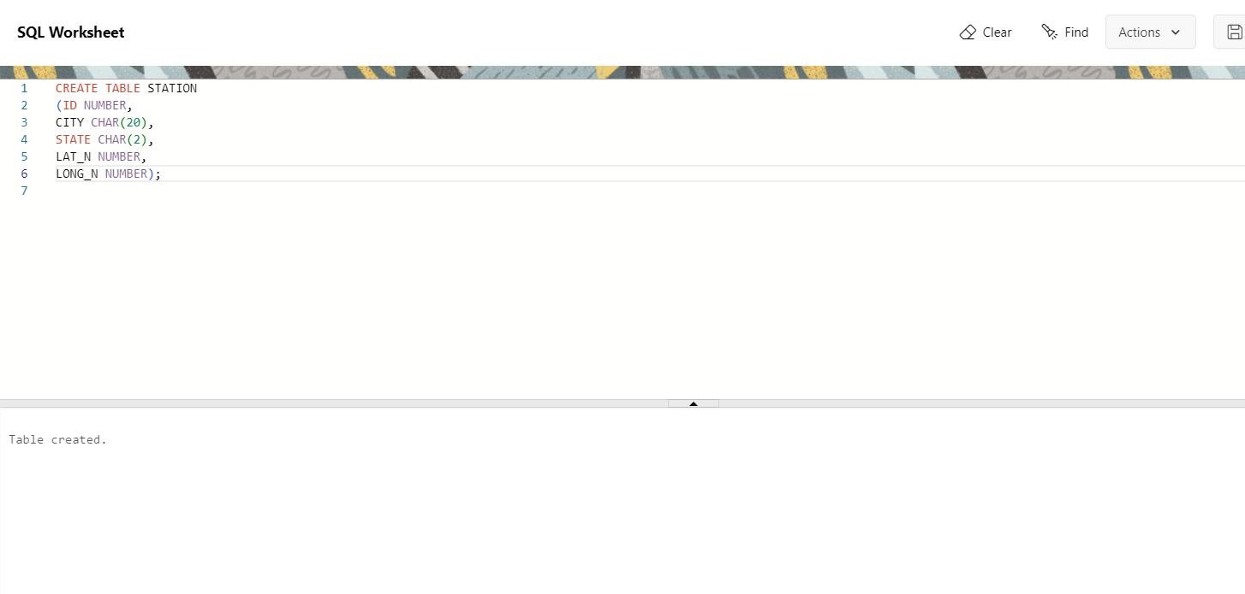

2. Insert the following records into the table:

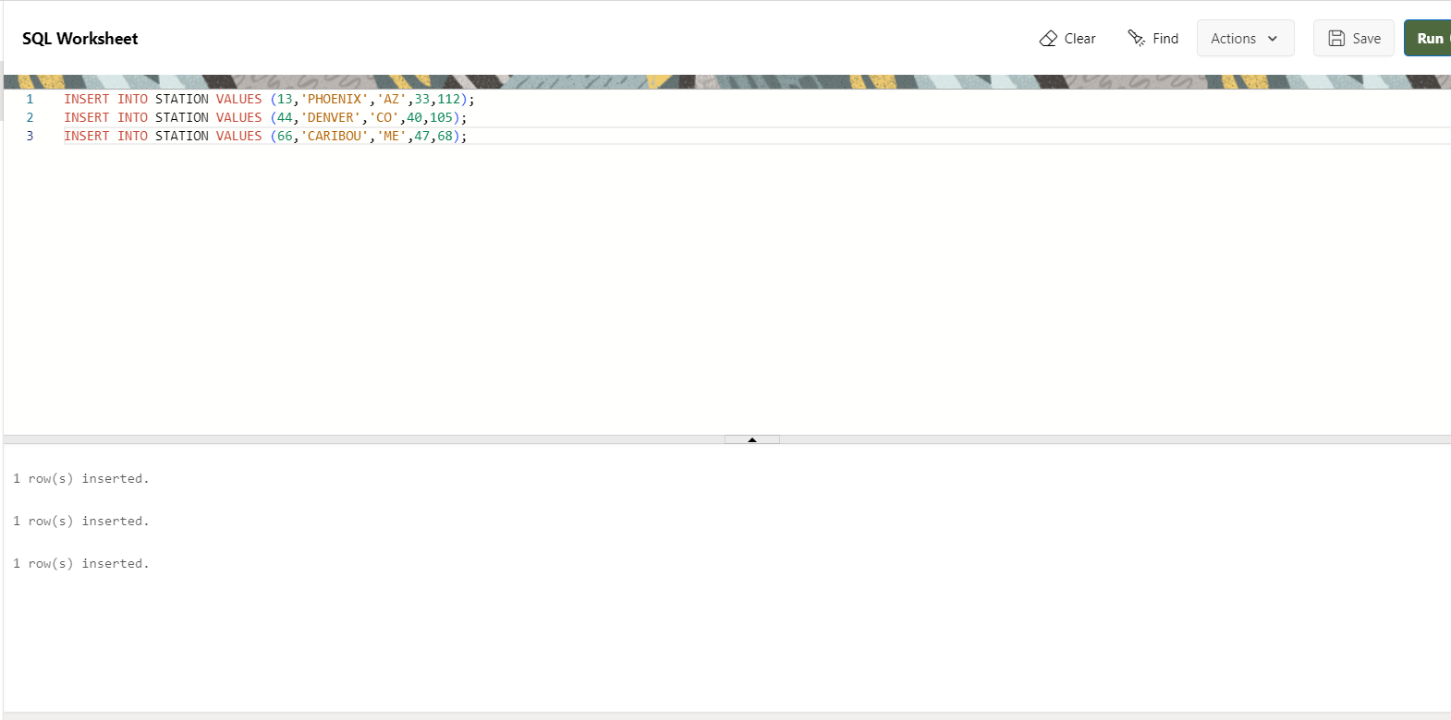

1. Execute a query to look at table STATION in undefined order.

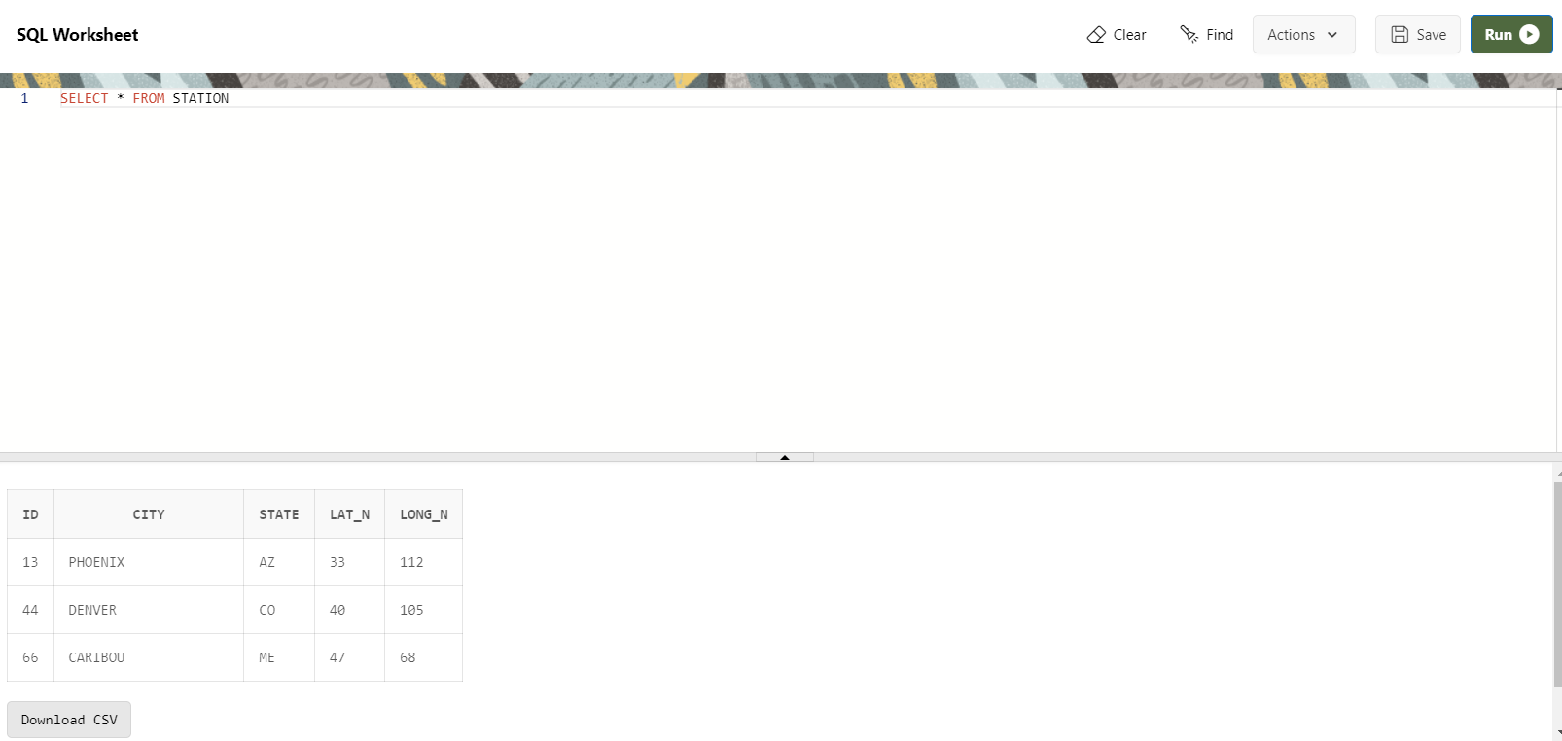

1. Execute a query to select Northern stations (Northernlatitude>39.7).

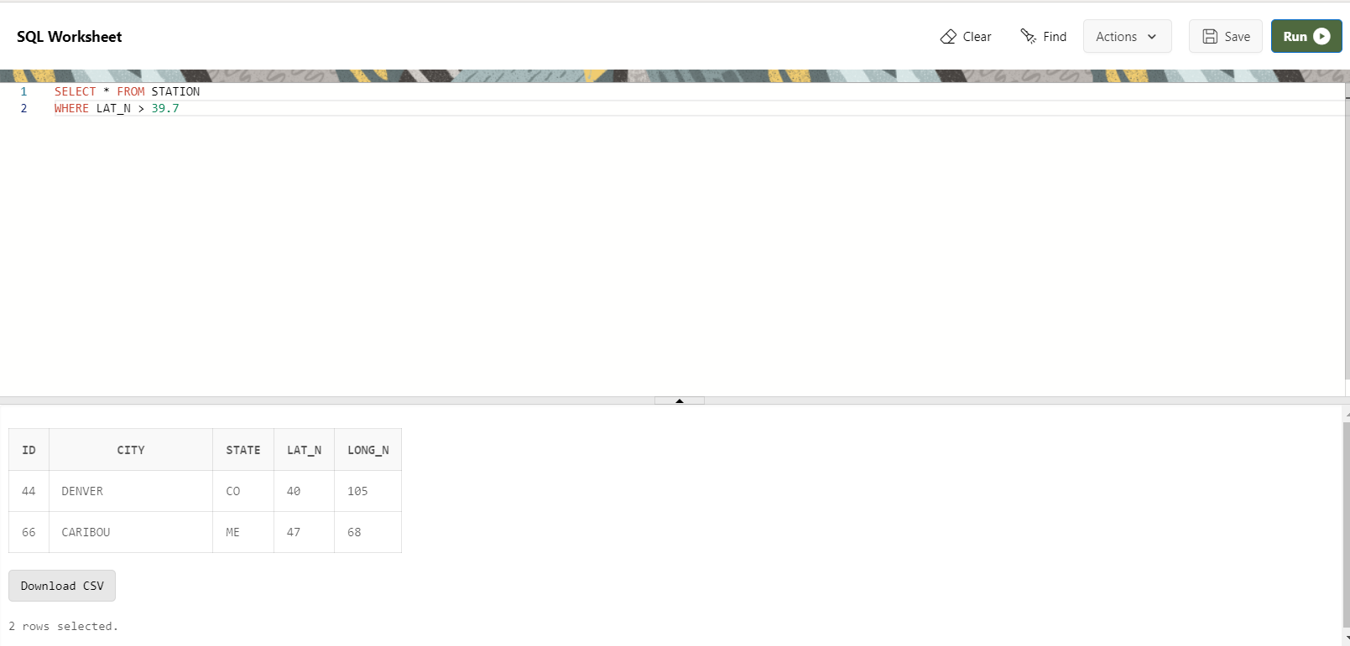

1. Create another table, 'STATS,’ to store normalized temperature and precipitation data

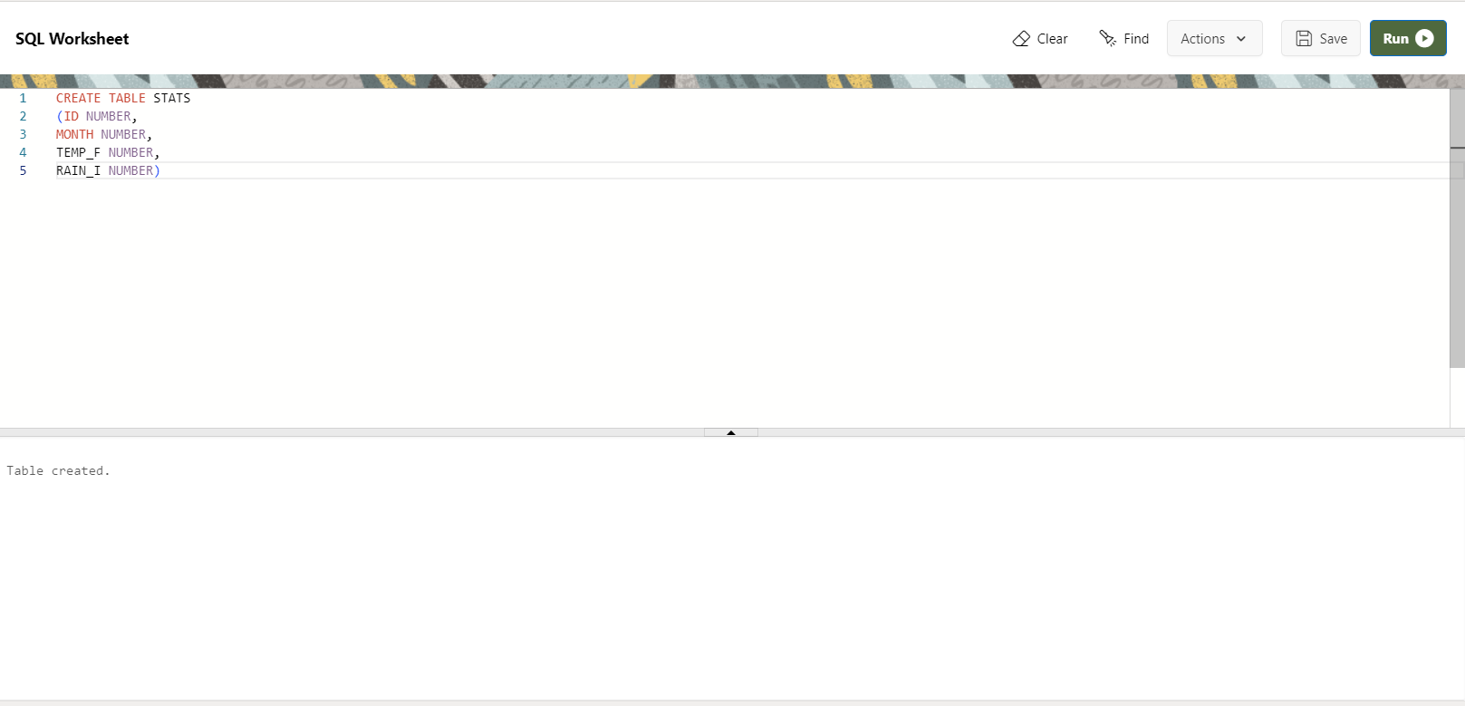

1. Populate the table STATS with some statistics for January and July

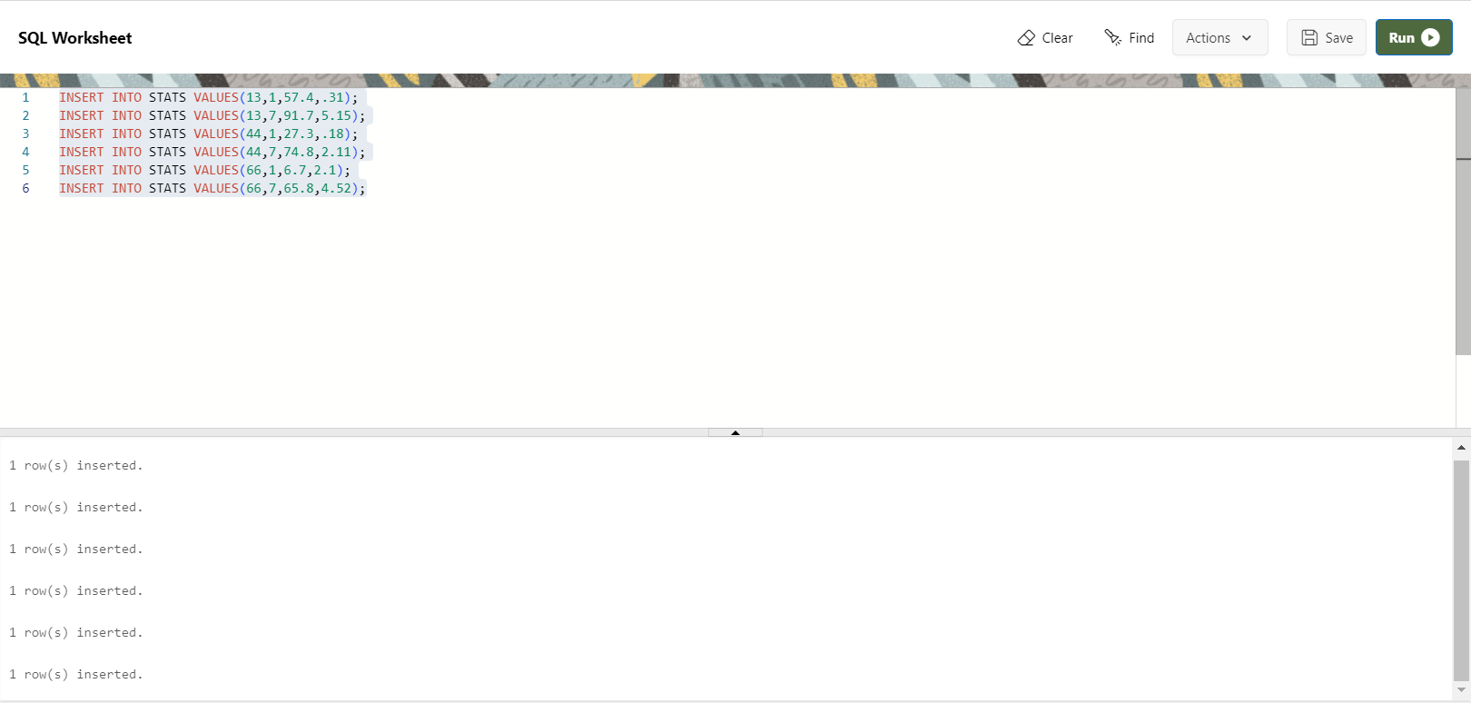

Display Table Stats  
  
  
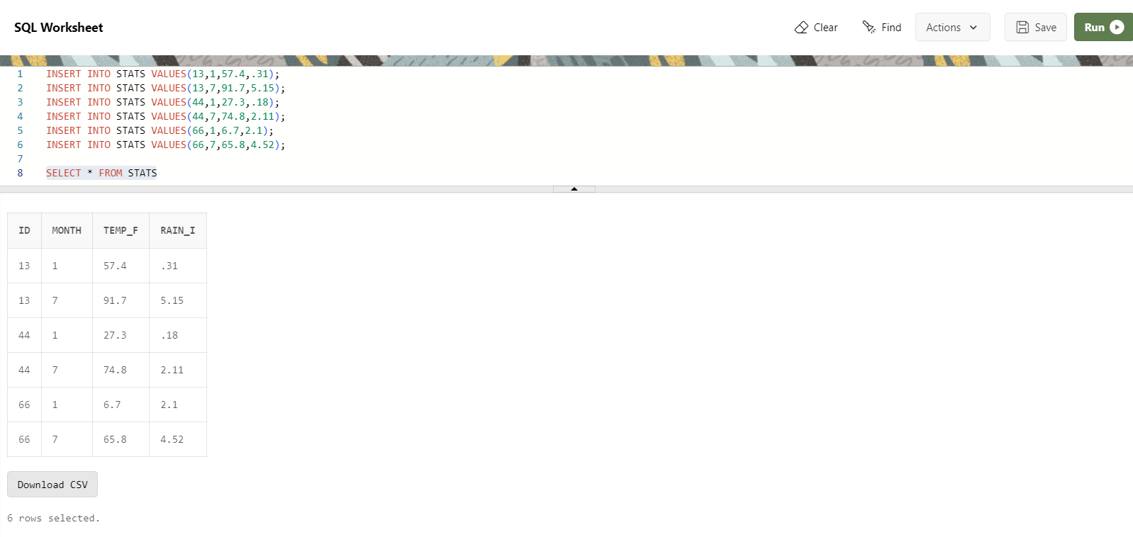

1. Execute a query to display temperature stats (from STATS table) for each city (from Station table).  
     
   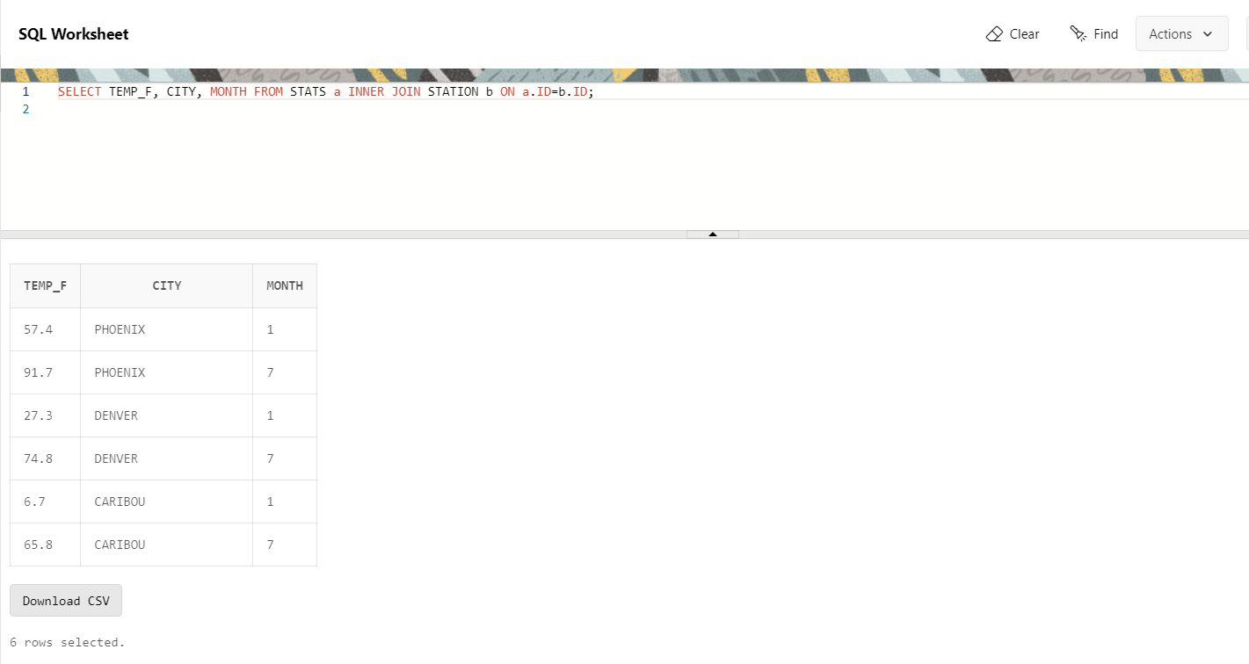

8. Execute a query to look at the table STATS, ordered by month and greatest rainfall, with columns rearranged. It should also show the corresponding cities.

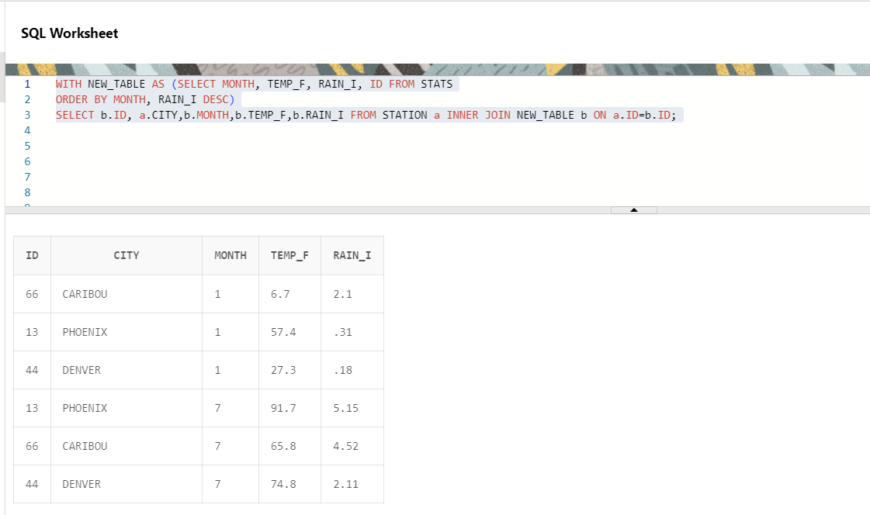

9. Execute a query to look at temperatures for July from table STATS, lowest temperatures\ first, picking up city name and latitude.

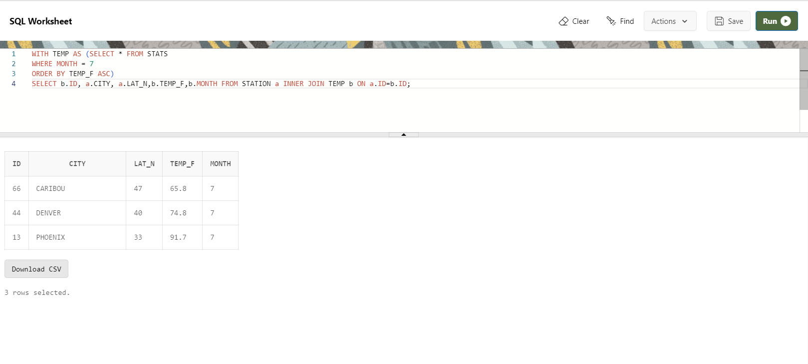

10. Execute a query to show MAX and MIN temperatures as well as average rainfall for each city.

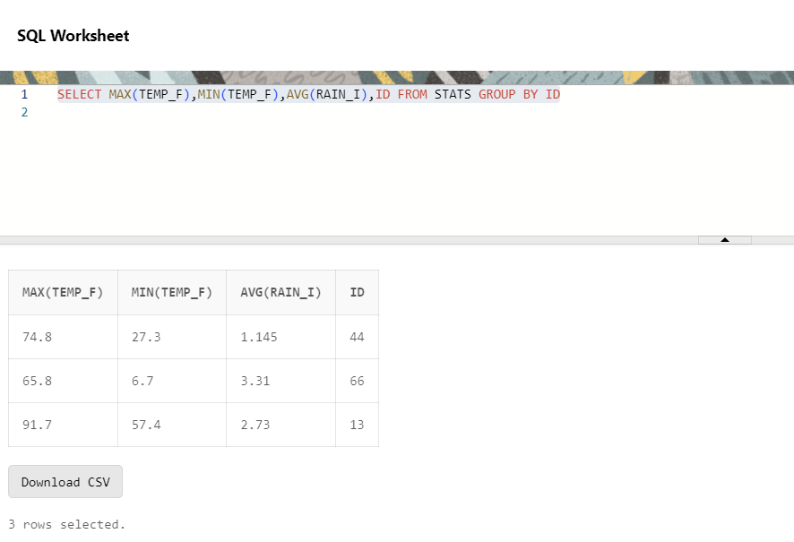  
  
11. Execute a query to display each city’s monthly temperature in Celsius and rainfall in Centimetre. (Create View)  
  
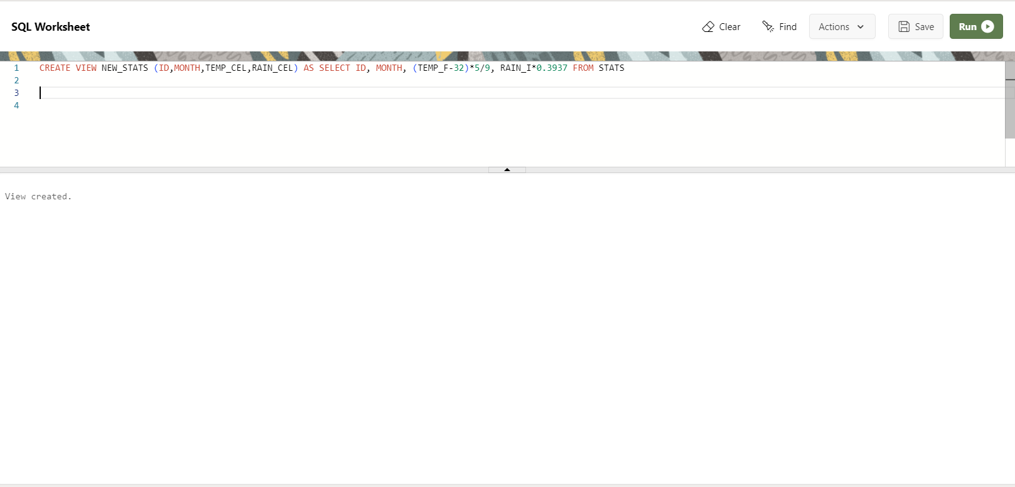  
  
  
  
Display From View  
  
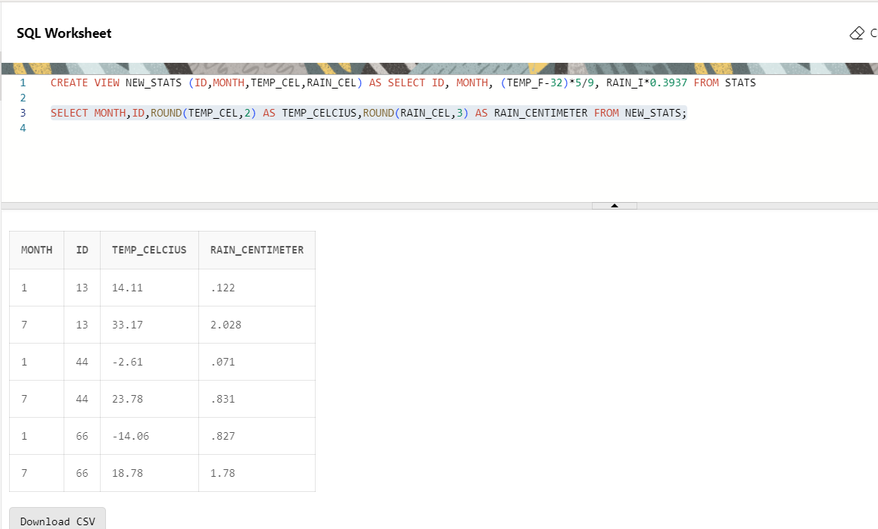  
  
12. Update all rows of table STATS to compensate for faulty rain gauges known to read 0.01 inches low.  
  
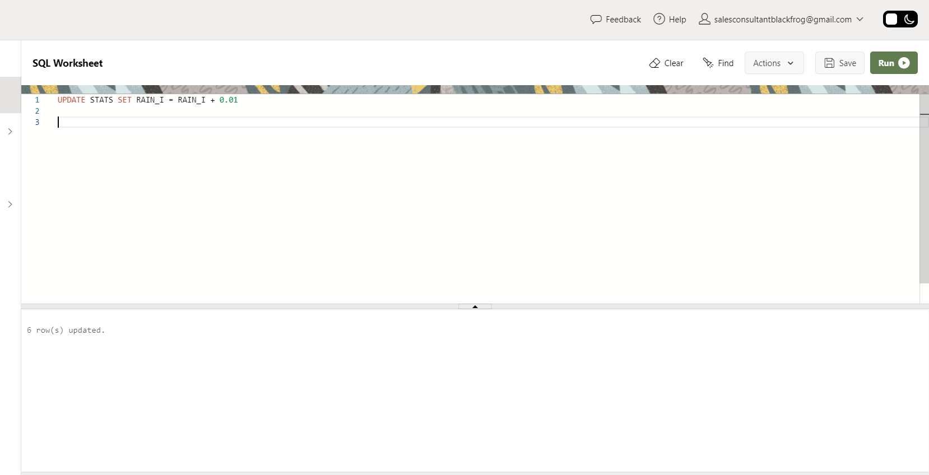

Display Updated Rows  
  
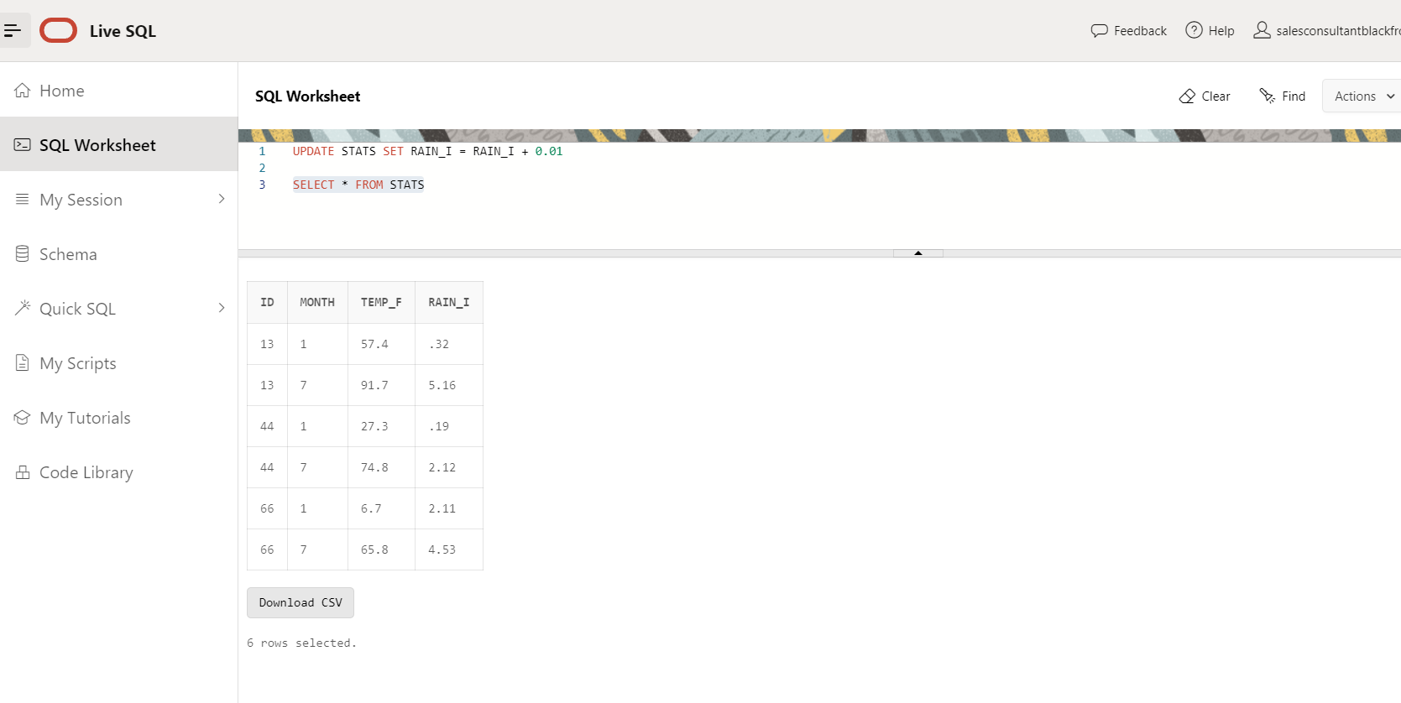  
  
13. Update Denver’s July temperature reading as 74.9  
  
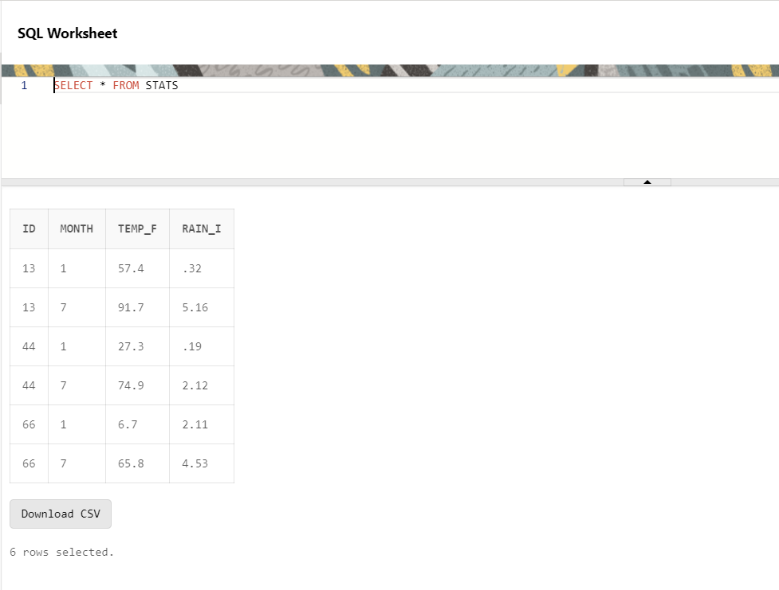

Display Updated Rows  
  
